**Assignment 3**

1. Sign up to Salesforce account.

After signing up go to Setup and click Developer Console

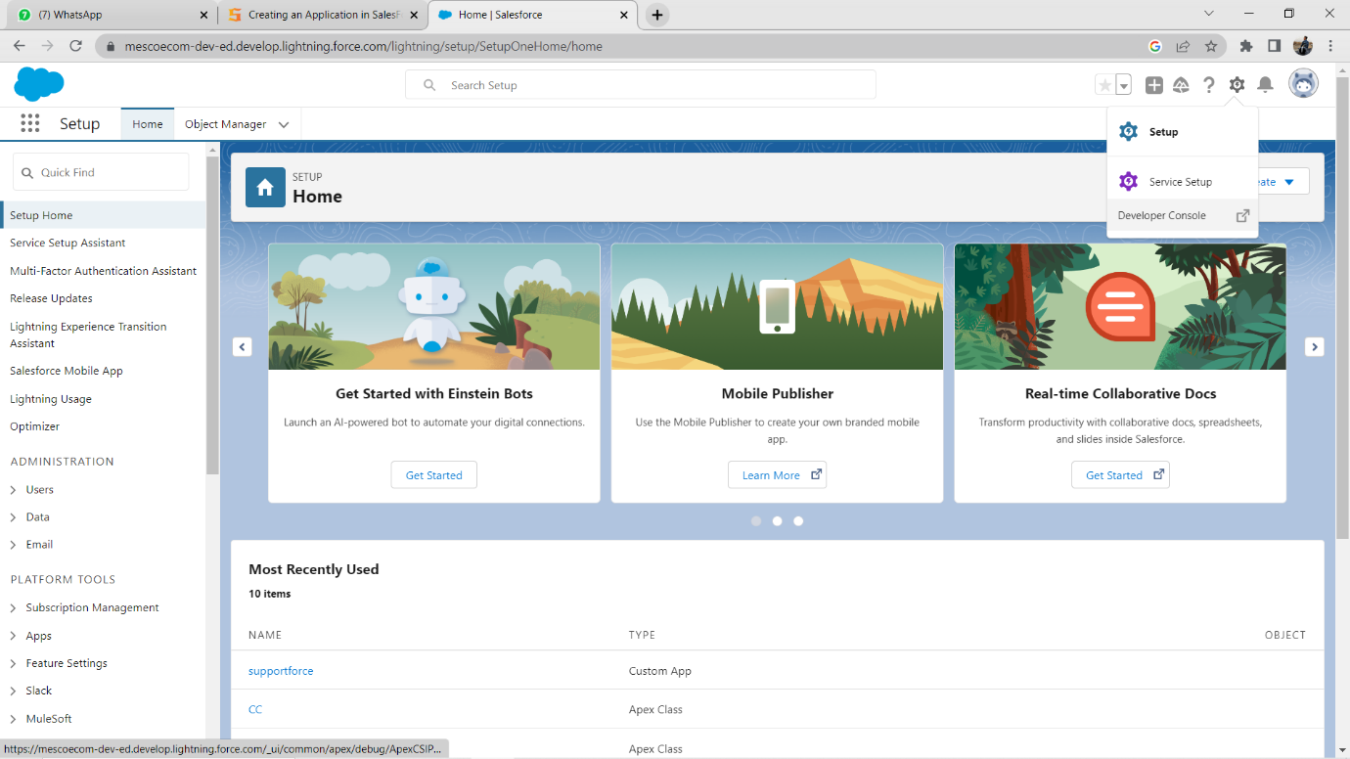

1. Click File- > New-> Apex Class and Name it as Black1 and Click OK

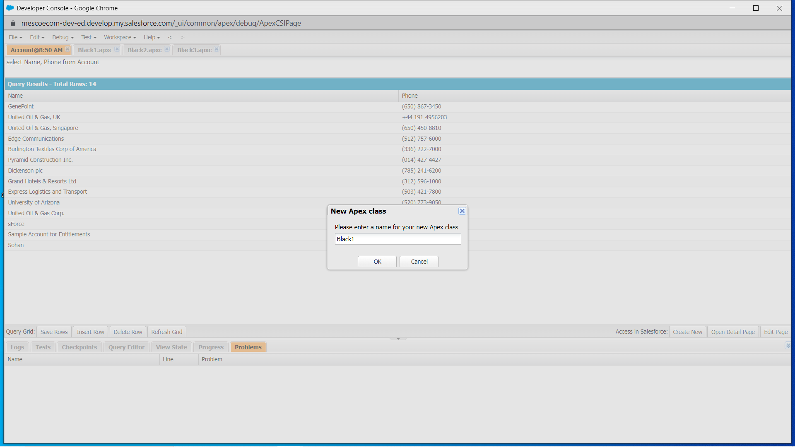

1. Write a code to create an account.

Don not forget to save the code

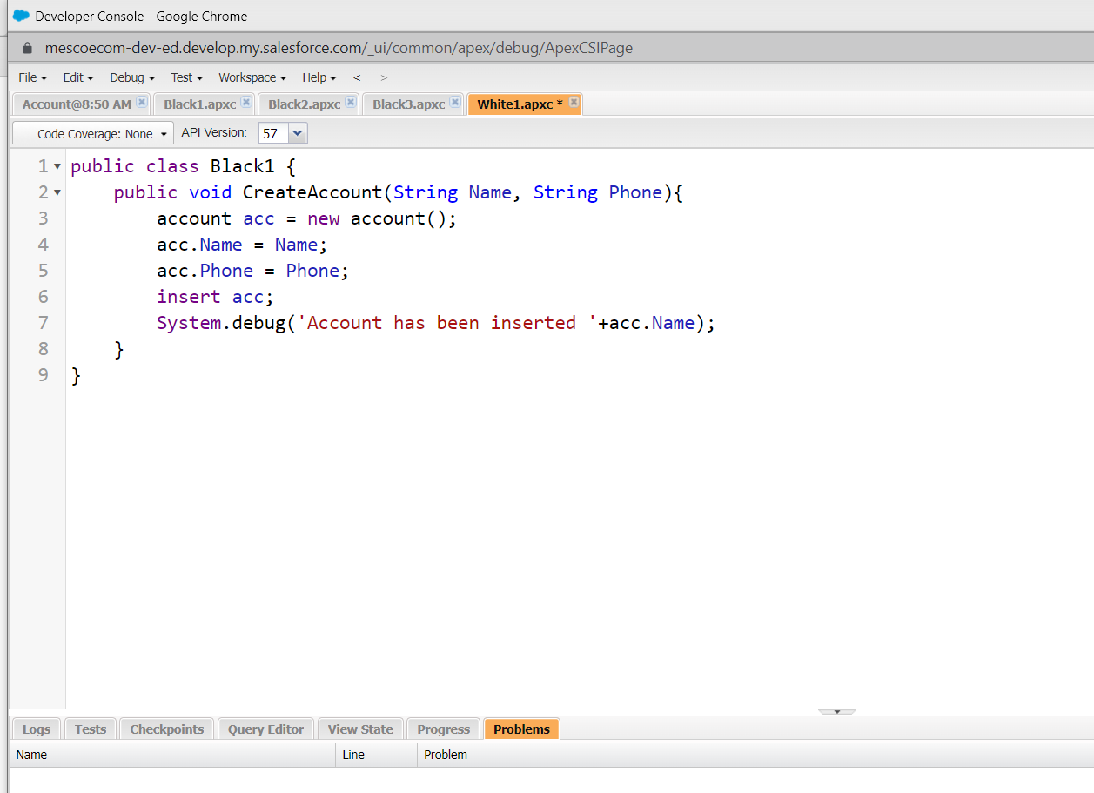

Click on **Debug** ->**Open Execute Anonymous** **Window** and write the code and then **Execute** it.

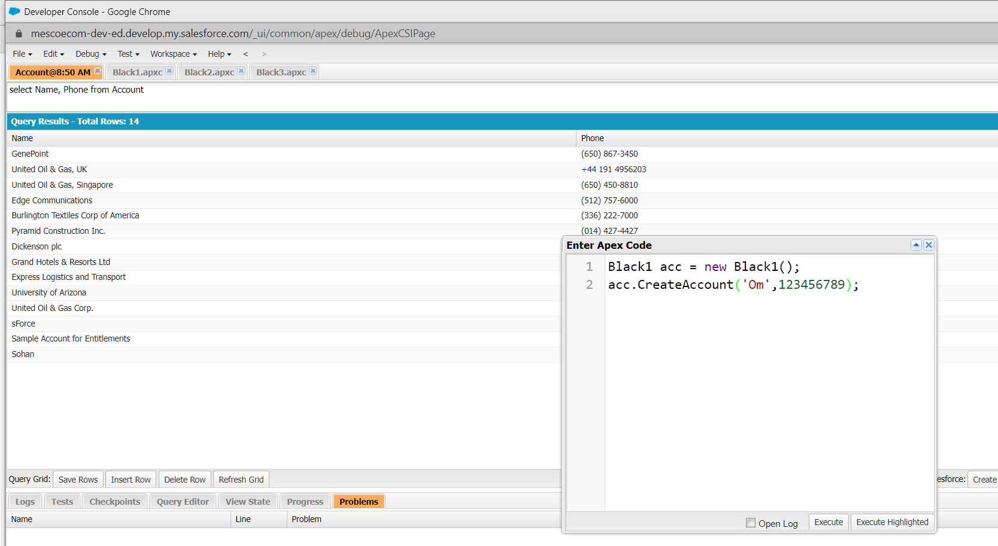

Can add multiple entries.

You can see record added successfully



To retrieve the records go to **Query Editor** and type the query language and **Execute** it.

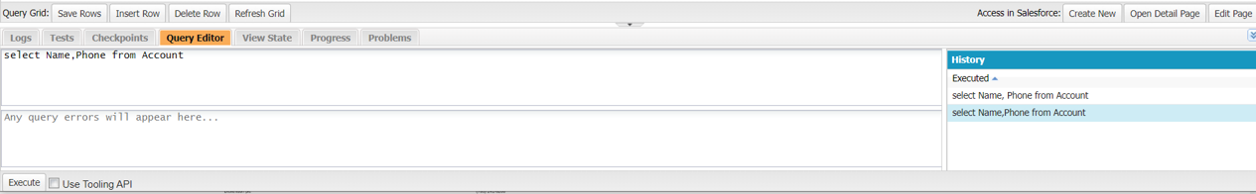

You can see the record added

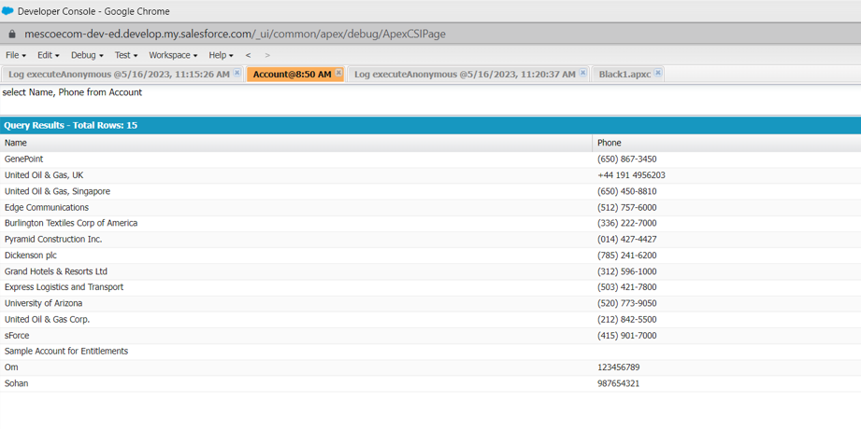

1. Write a code to update an account

Follow the same steps: **File** -> **New** -> **Apex** **Class** and name it as **Demo2**.

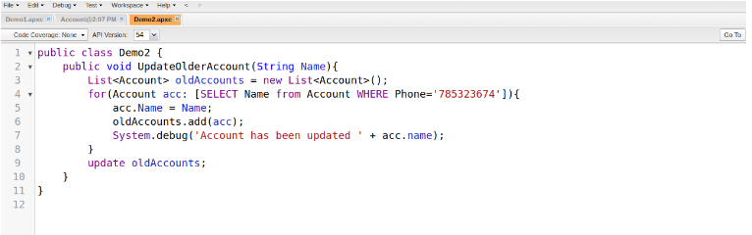

click on **Debug** -> **Open** **Execute** **Anonymous** **Window**and write the code.

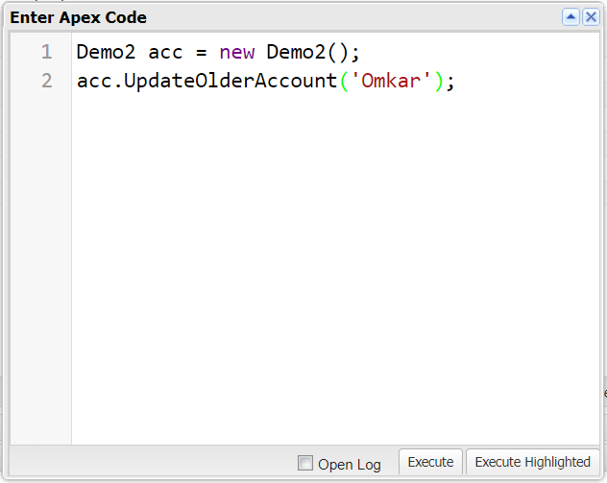

View the record in Salesforce

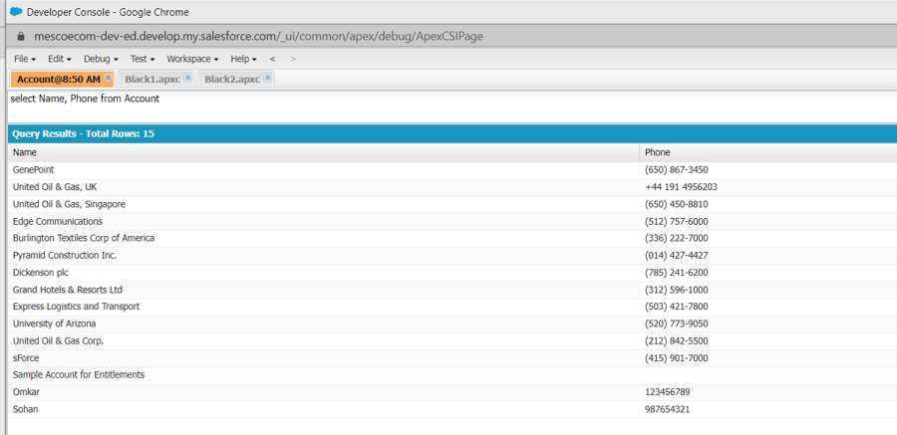

1. Write a code to Delete an record

 steps: **File** -> **New** -> **Apex** **Class** and name it as **Demo3**.

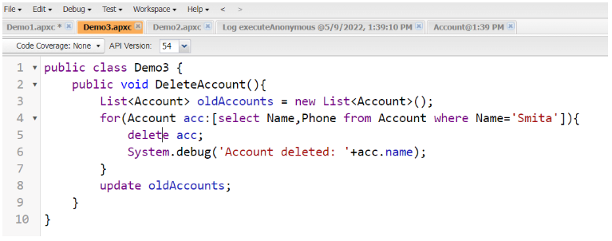

Instead on Name=’Smita’ in code write the name of record that you want to delete

click on **Debug** -> **Open** **Execute** **Anonymous** **Window**and write the code.

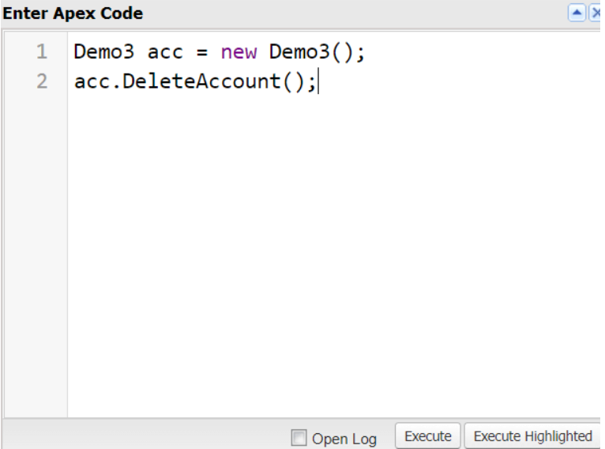

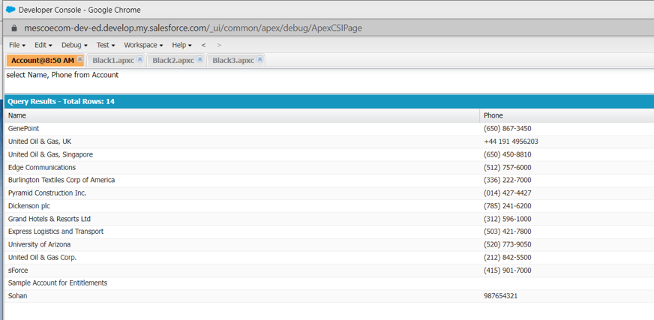

No Record for Omkar is found here.

You can also check if record is deleted by following ways:

To view the records in Salesforce go to **Setup** and search for **Accounts** and click on it.

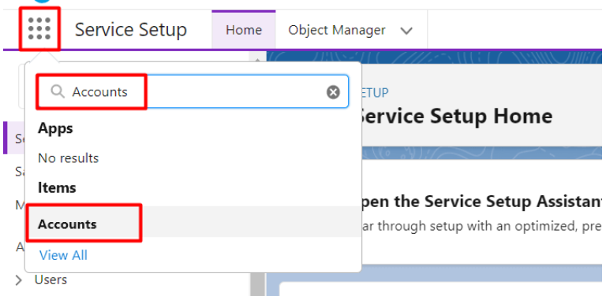

Before Deletion:

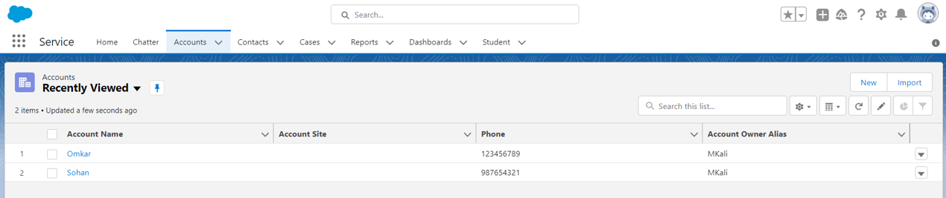

After Deletion:

